Dungeon Searcher – Game Story

Mark Floorlock was a treasure hunter; often people would learn about a suspected one being located somewhere, and hired him to retrieve it. Often he had to sneak or fight his way past guards- both police, monster, and ancient guardians alike. Right now, he was several floors deep in a hidden dungeon, and had already encountered several crawl creeps (a common type of monster) but worse was to come.

Right now he was actually working for Sasha, one of his town’s richest citizens. This dungeon was originally created and used by a now extinct race who lived on the planet before known as the Prosperers. They were quite advanced, but started to die off after the outbreak of a devastating disease; or so the ancient logs left behind said. Much of the writing had worn off after 300 years. Legend has it that one of the things they stored at the bottom of the dungeon were well preserved schematics for much of their technology. If Mark could recover it, Sasha would pay him well, and the tech companies would pay her well. Things would be quite different…

You’re Mark, and it’s your job to find the needed container with the schematics, but without dying first. Can you do it? Or will you perish in a fight?

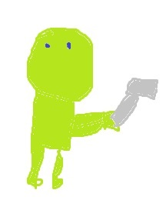Mark Floorlock (above)

A “Crawl Creep”

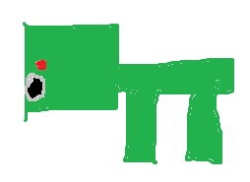A Bazooka Monster.